Training Notes for the Warco GH1330 Lathe Part 1

Safety.
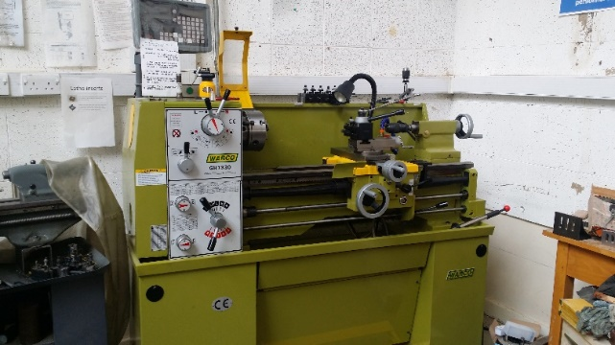
A lathe is potentially one of the most dangerous machines in a workshop, however if correctly used it is extremely safe.
It is you that makes the difference.

Always make sure of two things when using a lathe:
1. That the work area is safe, there is nothing lying on the lathe that shouldn’t be, especially the chuck key, more on that later. Ensure that your work is held firmly in the chuck, also check before starting the lathe that the feed drives are not engaged that the chuck will not collide with any tools.
2. You have nothing on you that can get caught in the mechanism of the lathe, beware of lose clothing, long sleeves, jewellery and especially long hair. All of these are a total No-no. Whilst eye protection is mandatory do not wear anything that will impair your hearing – if you listen to the lathe while it cuts the lathe will tell you how well you are doing. Never wear gloves whilst using the lathe, however it is wiser to use them when cleaning up afterwards.

Getting to know your lathe
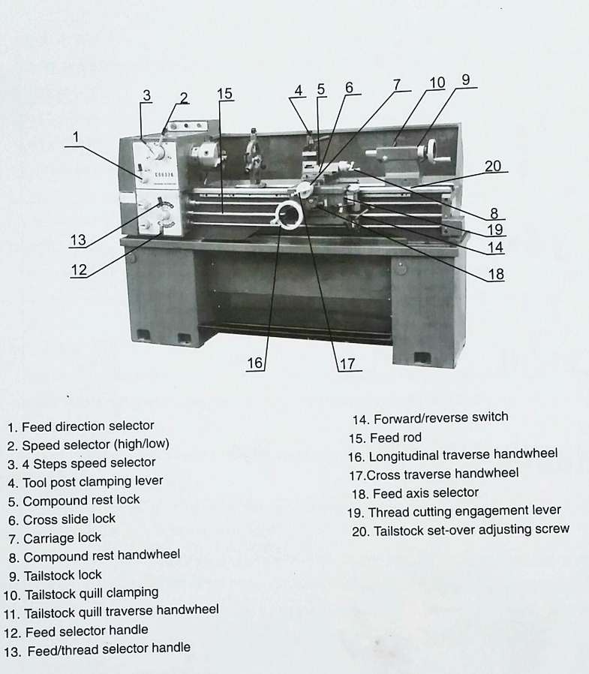
Parts of your lathe – your trainer will demonstrate the function of each part

Setting up your lathe
Switch on the wall and the e-stop released, the power light comes on. If you power up with the forward/back lever in the run position you have to go to neutral first then reselect.
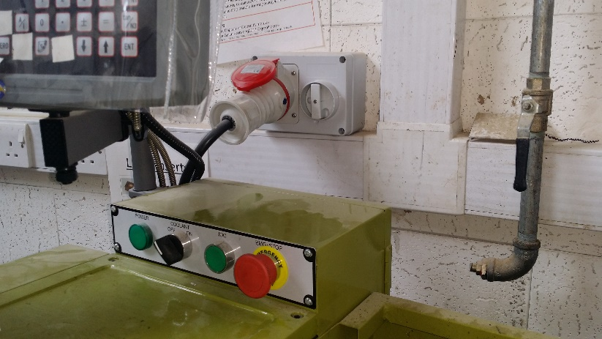

Checking the lathe.
Do a visual check to see that your work area is free from items that could fall into the lathe or become entangled in the lathe.
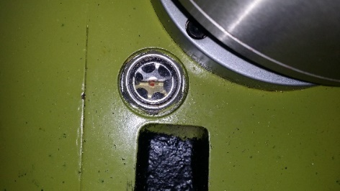
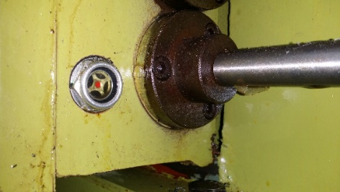
Lubrication/oil checks. There are three oil windows which should have oil halfway up the glass.
If they do not this is a major panic but report it to management. There are sight glasses for spindle gearbox, lower gear box (lead screw), and carriage.

Select Speed.
Spindle MUST be stationary. They are crash gears with no concept of synchromesh, so the spindle has to be stopped entirely. Nudge chuck by hand until meshing happens. The guard must be closed to start system.
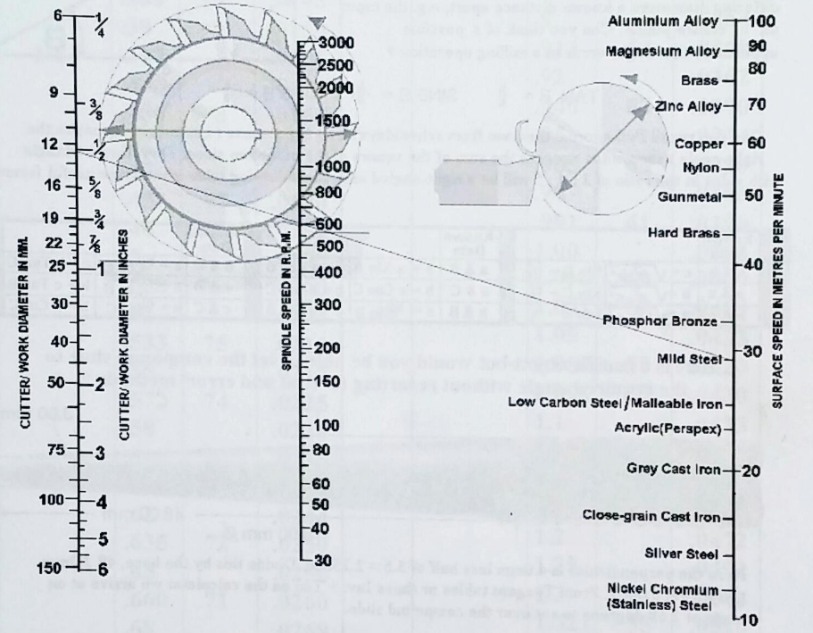
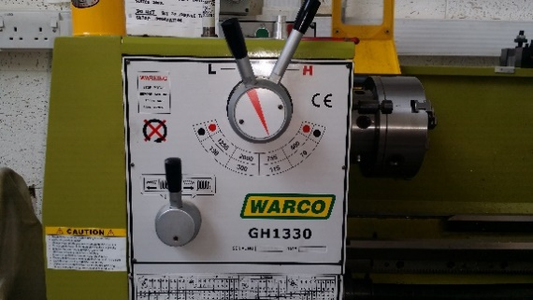

Preparing the job
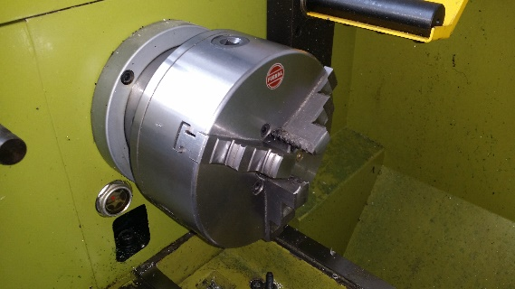
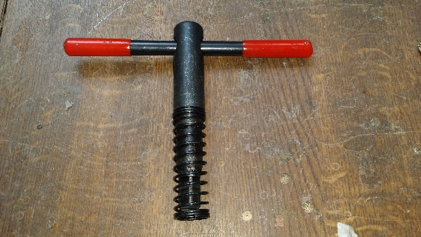
The 3 Jaw Chuck Chuck Key
The main chuck is 3-jaw chuck. We also have a 4-jaw chuck, which is used for irregular shaped items.
Always leave the 3-jaw chuck on the lathe when done, some people cannot mount and de-mount the 4-jaw safely as it is very heavy. Phase 2 of the training covers changing chucks.
One of the most dangerous things that you can do on a lathe is to leave the chuck key in the chuck
First check that the chuck is correctly fitted and tight in its mounting, your trainer will demonstrate how to do this.
Now place your job in the lathe Cutting tools should all be set for centre height
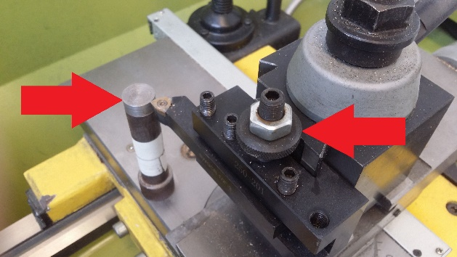
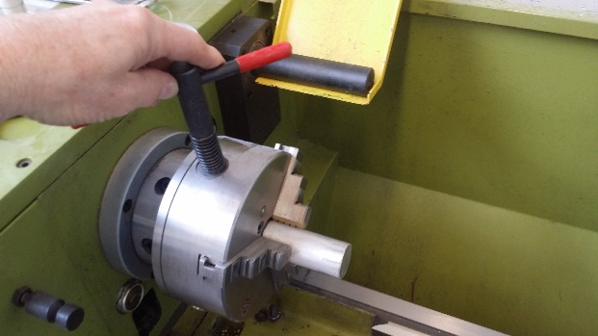

Place the bar centrally into chuck, tighten up nicely. The first job is usually facing off, getting the manky end square.  Get a good end to start from. | Tools should all be set for centre height. Drop-in and tighten should give you the correct height, but it's best to check. Big spanner to loosen quick-change tool to rotate it. You can re-align it by coming up to chuck, which is the best square. Loosen off, bring up to chuck, and tighten. The spring washer stops the nut vibrating. A little beyond humans doing finger tight.  Centering is absolutely vital with parting-off tools. Make sure all is tight there. Usually only displace/swing for taper turning.  Don't use it for fine feeds - the DRO does not follow it.

Starting your lathe
The guard must be closed to start system.
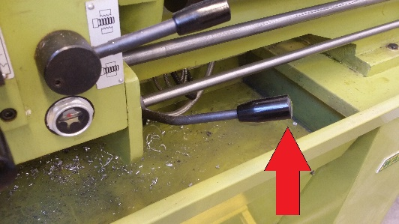
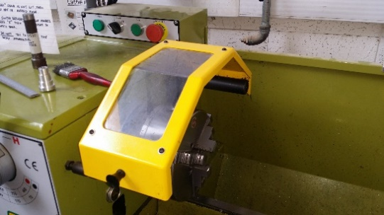
Starting on right-hand handle.
Rock to right and down for forwards. Knock it up to coast to a stop. Faster stop is foot pedal.

Emergency Stop Foot Pedal
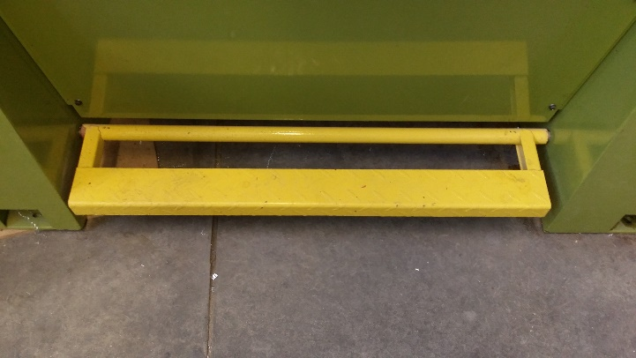
Slight touch switches the motor off and further push engages brake drum and stops it dead. The emergency brake should not be used for normal stops as it wears the brake.

Cutting tools
May be right and left-hand (approach from right/left). If cutting back into a shoulder you'll want a left-hand. Parting off tools, carbide and steel. Feed in gently so it doesn't dig. Various other tools, including for boring. The faces of the quick-change tool are at right angles, so you can bore.
- High speed steel tools give a finer finish but generally require more maintenance – left of picture
- Carbide tipped tools cannot have the cutting edges changed – centre of picture
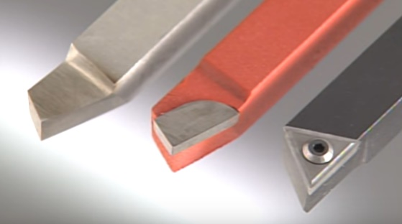
- Carbide insert tools are designed for toughness, and not surface finish – right of picture

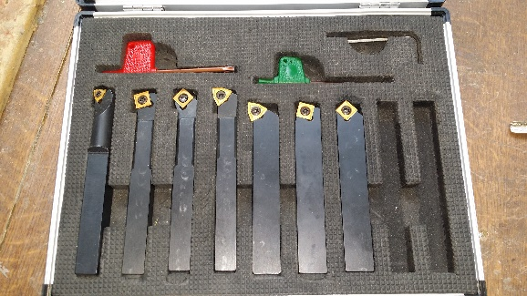
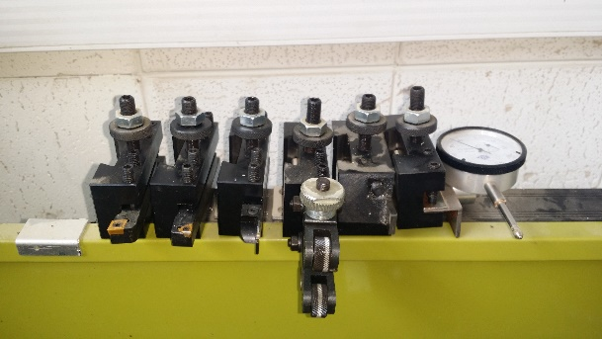
Makespace cutting tools

Quick Change Tool
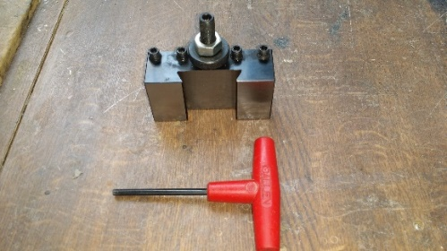
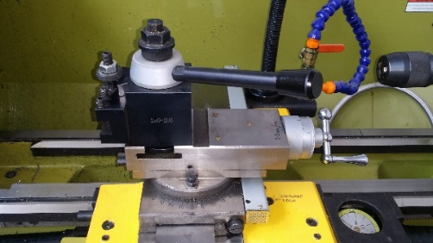
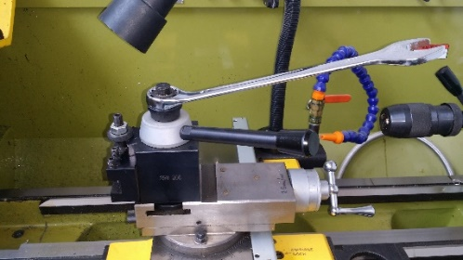
The big spanner is used to loosen the quick-change tool and rotate it. You can re-align it by bringing it up to the chuck and checking it is square to it and tighten it again.
- The tool holders are drop-in and tighten type and normally give you the correct height, but it's best to check
- Being square is absolutely vital with parting-off tools. Again, make sure all is tight here.
- Usually, you would only displace/swing the head for taper turning, see training part 2.
- Don't use it for fine feeds - the Digital Read Out does not follow it. The DRO is covered in part 2

Cutting Notes
- Square inserts are for heavy rough cuts and don't go right up to a shoulder.
- Chamfer bits exist, and so do thread cutting bits, as do internal/external cutting bits. (more on part 2 of the course).
- Chamfer bits are better when re-angling end of your work.
- The tools that are along the back of the lathe should be kept there
- Replacing tools means you will have to adjust the height nut on each cutting tool. Lock and then re-test. Spring washer stops the nut vibrating. Tighten a little beyond humans doing finger tight.
- All tools have a tiny radius at the end, so if you are cutting up to a shoulder you can either undercut a little and sink the radius in, or you can undercut the shank. A lot of times it doesn't matter, until you need to fit a bearing.
- Plan to cut slightly larger than your final cut and measure prior to cutting the last cut and do a very fine cut.

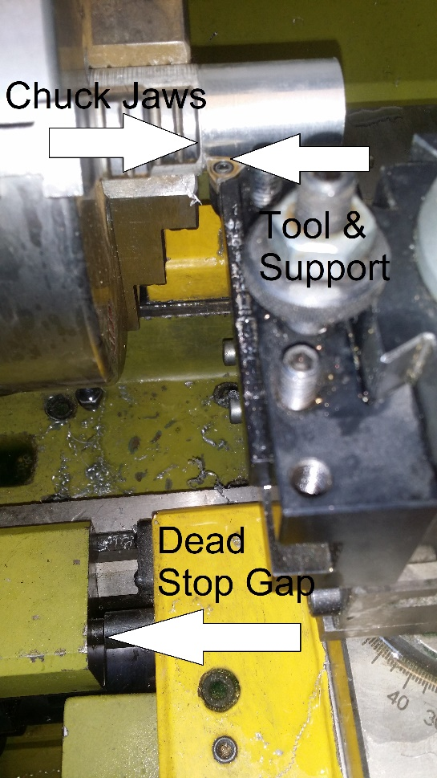
Dead Stop
Is used to prevent you driving the cutting tool and its mounting into the rotating chuck, which is another big No-No in lathe working and it will send you back to retraining, if the lathe is still working that is.
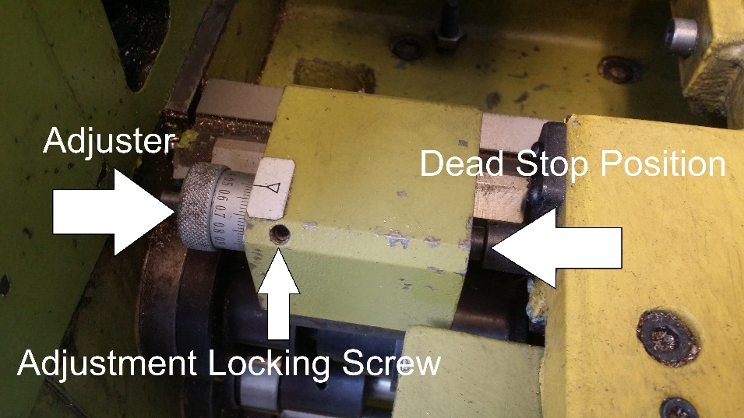
Adjustable with dial. It is used whilst hand-feeding only.

Lubrication
You may use the built-in pump system which can be messy or the hand pump oil can that lives with the lathe.

Cross cut (end or face cutting)
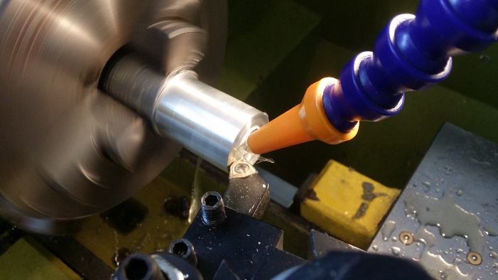
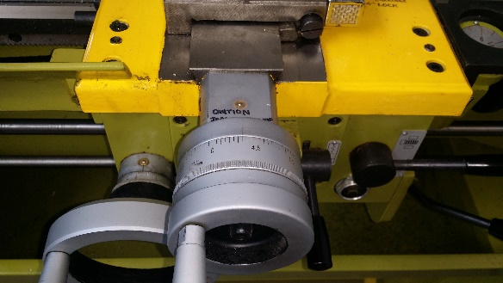
Face Cutting is done by cutting across the end of the metal and using the cross feed which is calibratd in DIAMETER. .5 mm is a .25mm infeed.
Your instructor will demonstrate a cut to you then you can do one, try both a manual cut and then a power feed one.

Long cut (turning)
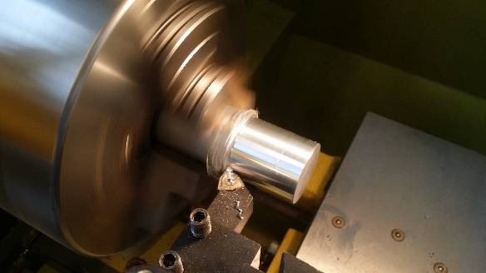
Turning is done by cutting down the rounded side of the metal and using the longitudinal wheel. Your instructor will demonstrate a cut to you then you can do one, try both a manual cut and then a power feed one.
Always plan to get your penultimate cut an extremely small amount short of your final cut, this way your final cut will be extremely fine and be smoother. Carbide inserts are designed for toughness, and not surface finish.
All tools have a tiny radius at the end, so if you are cutting up to a shoulder you can either undercut a little and sink the radius in, or you can undercut the shank. A lot of times it doesn't matter........until you need to fit a bearing.

Always be careful that you do not drive the cutting tool into the moving chuck, particularly when using the power feed.

Tail Stock

Centring tool
- Lock off slide and advance with longer handle at the rear.
- Tools vary, so leave plenty of room.
- Centre drill first using centering tool
Centering tool in the tailstock chuck The Makespace set of centering tools
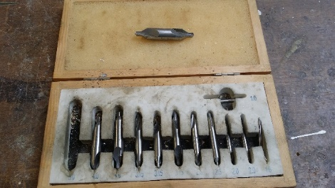
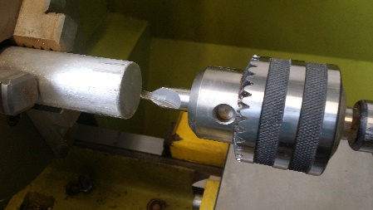

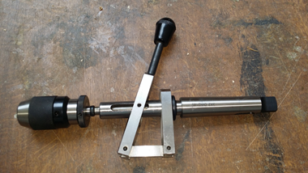
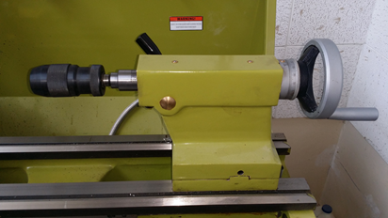
Tail Stock with standard chuck Lever type tailstock chuck
The lever-action drill head is for smaller drill bits, and gives you some feel of how the cut is going.
Power feed.
- Take the tool well clear of the work and make sure the lathe is working correctly before you start to cut
- Check you have set the correct direction
- It’s always better to run slower and a better surface usually results.
- Cross feed or transverse-feed drive is selectable, but only one at a time.

Evaluation
Demonstrate that you understand the following:
- All matters safety related
- How to start up the lathe
- How to chose the correct speed for the job and how to select the speed on the gearbox
- Mount a job in the 3-jaw chuck and use of the safety cover
- How to set up the quick release tool spindle with the tool and set the correct angle
- Demonstrate an understanding of the different types of cutting tools and when you would use them
- Demonstrate how to set up the power feed and run it
- Set up the dead stop and the emergence stop foot pedal and show how they work
- Explain the difference between the calibration on the apron and the cross slide
- Show how to use the tailstock and centering tool to drill a hole into the end of a job

Shutdown at end of work.
Hit e-stop and then turn off at wall.
Cleaning: leave it clean!
Take work out, replace all the bits you may have changed/removed, brush stuff off the swarf from slides and other surfaces with the paintbrush and swarf. Brush it down to the collecting tray below, which can then be pulled out and emptied.
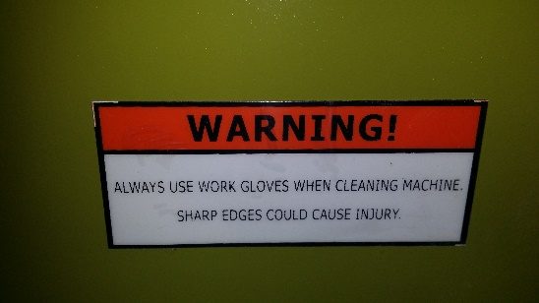
For clearing up gloves are mandatory. Swarf is razor sharp and can go septic if it gets under your skin. Gloves are kept in the blue bin just outside the secure workshop door
Author: Alaric Worrod 2018-06-04a

